SQL PROJECT- MUSIC STORE DATA ANALYSIS

1. Who is the senior most employee based on job title?

SELECT TOP 1 * FROM employee ORDER BY levels DESC



1. Which countries have the most Invoices?

select TOP 1 billing_country, count(*) as Invoice_count from invoice group by billing_country order by Invoice_count desc;

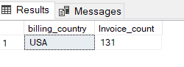

1. What are top 3 values of total invoice?

select TOP 3 total from invoice order by total desc;

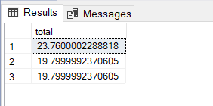

1. Which city has the best customers? We would like to throw a promotional Music Festival in the city we made the most money. Write a query that returns one city that has the highest sum of invoice totals. Return both the city name & sum of all invoice totals

select Top 1 billing_city, sum(total) as Total_Invoice from invoice group by billing_city order by Total_Invoice desc;

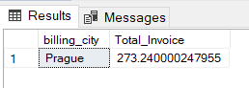

1. Who is the best customer? The customer who has spent the most money will be declared the best customer. Write a query that returns the person who has spent the most money

select Top 1 customer.customer_id, customer.first_name, customer.last_name, sum(invoice.total) as Total_Invoice from customer join invoice on customer.customer_id = invoice.customer_id

group by customer.customer_id, customer.first_name, customer.last_name order by Total_Invoice desc;

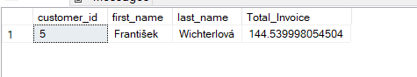

1. Write query to return the email, first name, last name, & Genre of all Rock Music listeners. Return your list ordered alphabetically by email starting with A

select distinct email,first_name,last_name,genre.name from customer join invoice on customer.customer_id = invoice.customer_id

join invoice_line on invoice.invoice_id = invoice_line.invoice_id

join track on invoice_line.track_id = track.track_id

join genre on track.genre_id = genre.genre_id where email LIKE 'a%' and genre.name like 'Rock' order by email ;

--OR

select distinct email,first_name,last_name from customer

join invoice on customer.customer_id = invoice.customer_id

join invoice_line on invoice.invoice_id = invoice_line.invoice_id

where track_id IN(

select track_id from track join genre on track.genre_id = genre.genre_id where genre.name like 'Rock' )

order by email ;

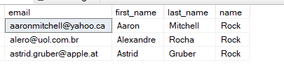

1. Let's invite the artists who have written the most rock music in our dataset. Write a query that returns the Artist name and total track count of the top 10 rock bands

select TOP 10 artist.artist_id ,artist.name,count(track.track_id)as track_count from artist join album on artist.artist_id = album.artist_id

join track on album.album_id=track.album_id

join genre on track.genre_id= genre.genre_id where genre.name like 'Rock' group by artist.artist_id ,artist.name order by track_count desc;

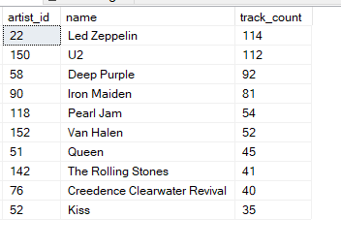

1. Return all the track names that have a song length longer than the average song length. Return the Name and Milliseconds for each track. Order by the song length with the longest songs listed first

select name, milliseconds from track where milliseconds > (select AVG(milliseconds) as avg_track_length from track) order by milliseconds desc;

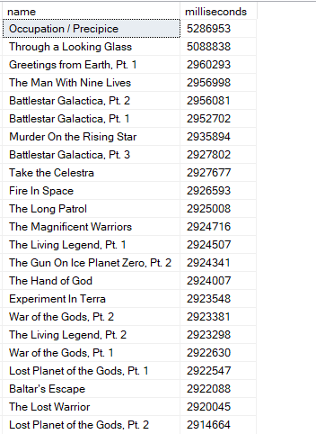

1. Find how much amount spent by each customer on artists? Write a query to return customer name, artist name and total spent

with best_artist AS(

select TOP 1 artist.artist_id AS artist_id, artist.name AS artist_name,SUM(invoice_line.unit_price*invoice_line.quantity) AS total_sales from invoice_line

join track on track.track_id = invoice_line.track_id

join album on album.album_id = track.album_id

join artist on artist.artist_id = album.artist_id

group by artist.artist_id, artist.name

order by total_sales desc

)

select c.customer_id,c.first_name,c.last_name,ba.artist_name,SUM(il.unit_price * il.quantity) AS amount_spent

FROM invoice i

join customer c on c.customer_id = i.customer_id

join invoice_line il on il.invoice_id = i.invoice_id

join track t on t.track_id = il.track_id

join album a on a.album_id = t.album_id

join best_artist ba on ba.artist_id = a.artist_id

group by c.customer_id,c.first_name,c.last_name,ba.artist_name

order by 5 desc;

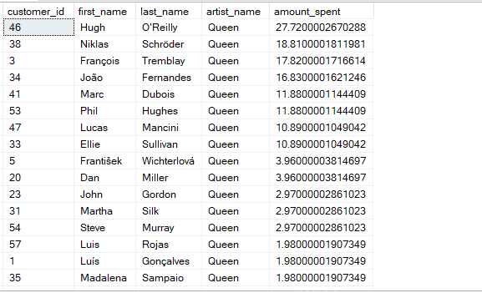

1. We want to find out the most popular music Genre for each country. We determine the most popular genre as the genre with the highest amount of purchases. Write a query that returns each country along with the top Genre. For countries where the maximum number of purchases is shared return all Genres

with popular_genre AS(

select count(invoice_line.quantity) as total_purchase,customer.country, genre.name,genre.genre_id,

ROW_NUMBER() OVER(PARTITION BY customer.country order by count(invoice_line.quantity) DESC) as Rowno from invoice_line

join invoice on invoice.invoice_id = invoice_line.invoice_id

join customer on customer.customer_id = invoice.customer_id

join track on track.track_id = invoice_line.track_id

join genre on genre.genre_id = track.genre_id

group by customer.country, genre.name,genre.genre_id

)

select * from popular_genre where Rowno <=1

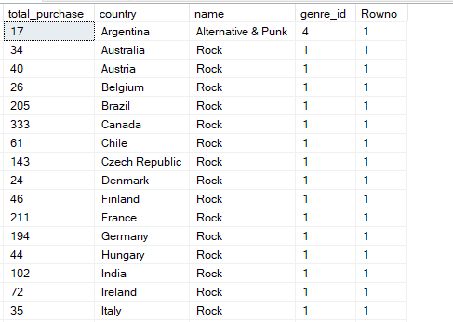

1. Write a query that determines the customer that has spent the most on music for each country. Write a query that returns the country along with the top customer and how much they spent. For countries where the top amount spent is shared, provide all customers who spent this amount

WITH customer_with_country AS(

select customer.customer_id, first_name,last_name,billing_country, SUM(total) as total_spending,

ROW_NUMBER() OVER(PARTITION BY billing_country order by SUM(total) DESC, billing_country asc) as Rowno

from invoice

join customer on customer.customer_id = invoice.invoice_id

group by customer.customer_id,first_name,last_name,billing_country

)

select * from customer_with_country where Rowno <= 1 order by billing_country asc, total_spending desc

